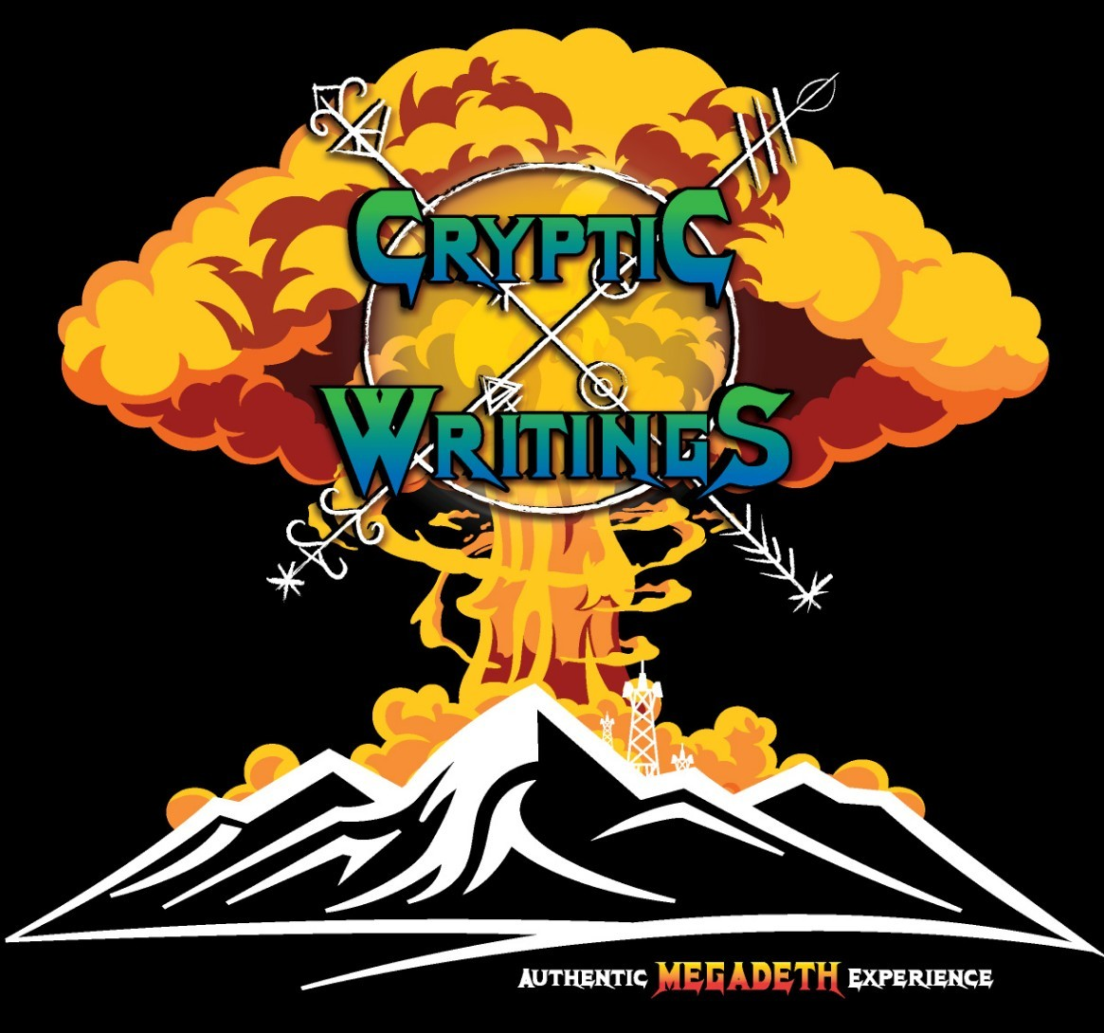

Cryptic Writings 2026 Production

Band Members
Phoenix Rose – Lead Vocals/ Guitar, and Tour Manager (719) 994-2941 rr5rocker@gmail.com
Jimie Rod – Bass Guitar / Backing Vocals (secondary contact) (719) 250-2755
Anthony Martinez – Lead Guitar / Backing Vocals
Lionel White - Drummer

Loading:
Purchaser to provide, when available, two capable people to assist the Artist with equipment load-in and load-out.
Unless otherwise noted. If otherwise noted we will have two to three crew members.

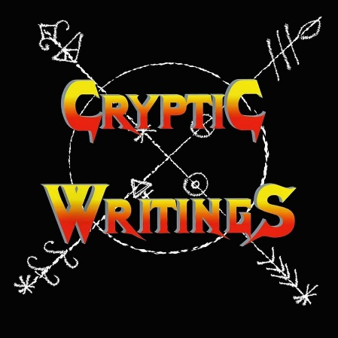

Cryptic Writings Equipment Rider

Guitar (Stage Right):
1 – Marshall JCM2000 or DSL100 Head
1 – Marshall 1960 Lead 4x12 Cab (Slant or Straight)

Bass (Stage Right):
1 – Ampeg SVT Classic Head
1 – Ampeg 8x10 Cab

Guitar (Stage Left):
1 – Marshall 100Watt JCM or JVM with effects loop
1 – Marshall 1960 Lead 4x12 Cab (Slant or Straight)

Drums:
Pearl Export Kit
- – 22” Bass Drum (with double kick pedal)
10” Rack Tom
12” Rack Tom
13” Rack Tom
14” Floor Tom
16” Floor Tom
14” Snare Sensitone Still

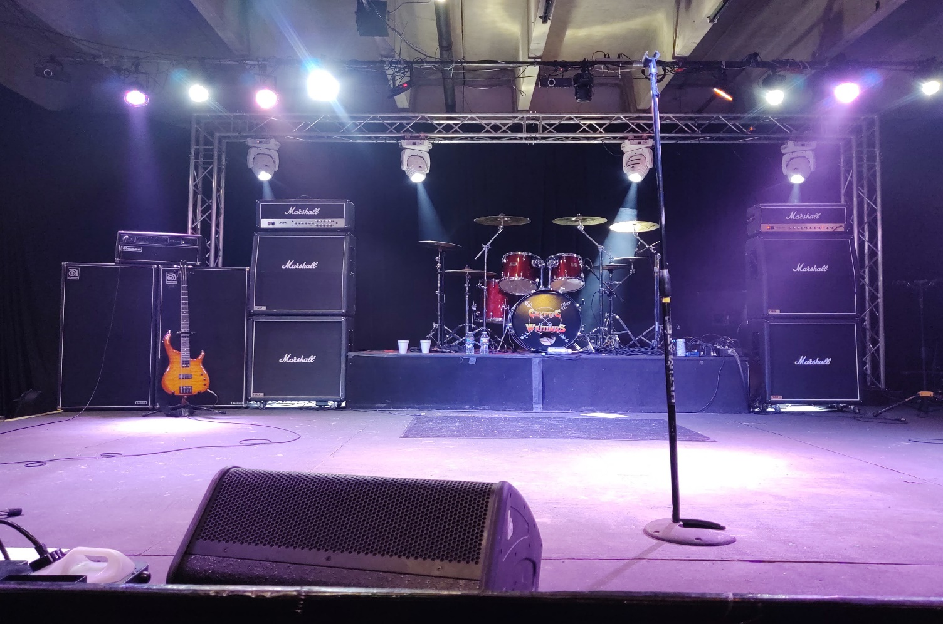

Front Stage

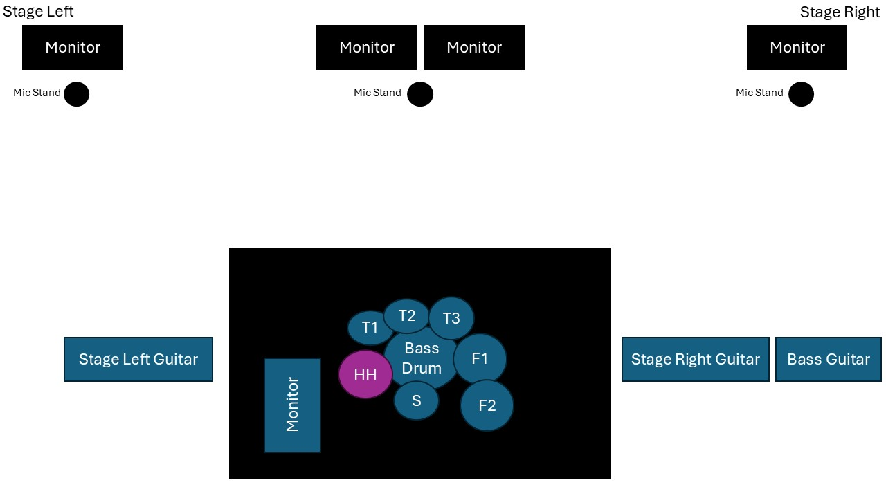

Cryptic Writings Input List

Input # | Instrument | Microphone | Stand Used | Other Notes
1 | Center Vocal | Shure SM58 Beta | Tripod Boom Stand
2 | Intro Tape | XLR Adapter |  | Need a long XLR to reach side stage
3 | Stage Right Vocals | Shure SM58 Beta | Boom Stand (round base preferred)
4 | Stage Left Vocals | Shure SM 58 Beta | Tripod Boom Stand
5 | Bass Guitar  (Stage Right) | Shure SM57 or Direct from Head
6 | Guitar  (Stage Right) | Shure SM57 or Equivalent | Boom or Clip on | No Line Out on Amp
7 | Guitar  (Stage Left) | Line Out Kemper
8 | Talkback Mic For Drummer | House Mic | Boom | Only for talking with soundman
9 | Bass Drum |  | Small Boom | Double Kick
10 | Tom 1 |  | Clip On
11 | Tom 2 |  | Clip On
12 | Tom 3 |  | Clip On
13 | Floor Tom |  | Clip On
14 | Floor Tom 2 |  | Clip On
15 | Snare |  | Clip On
16 | Hi-Hat
17 | OH S/L |  | Tall Boom
18 | OH S/R |  | Tall Boom

Cryptic Writings Master Song List

Holy Wars
Hangar 18
Take No Prisoners
Five Magics
Poison Was The Cure
Lucretia
Tornado Of Souls
Dawn Patrol
Rust In Peace
Skin O’My Teeth
This Was My Life
Sweating Bullets
Countdown To Extinction
Symphony Of Destruction
Peace Sells
Kill The King
Angry Again
Hook In Mouth
She-Wolf
Elysian Fields
Head Crusher
Set The World Afire
Dread In The Fugitive Mind
99 Ways To Die
Washington Is Next
We’ll Be Back
Mechanix
Medley (Trust/Reckoning Day/ In My Darkest Hour)
Wake Up Dead
Dystopia
Back In The Day
1000 Times Goodbye
Addicted To Chaos
My Last Words
One Thing
Kick The Chair
Fatal Illusion
The Disintegrators
Ashes In Your Mouth

Intro Tape:
*Prince Of Darkness*

Full Album Performances:
Rust In Peace

Hospitality Rider

If the venue is equipped with a grill, 1 comp meal and drink (soda/tea) per band / crew member.

If the venue is not equipped with a grill, catering is accepted or some form of “finger food” will suffice.

*Please Note: One band member is allergic to Raw Tomatoes*

Finger Food Style Foods:

Veggie / Fruit Tray
Mini Sandwiches / Pinwheel Roles
Cracker / Meat/ Cheese Tray

Water / Gatorade provided for Band / Crew onstage / in green room.

Band is in need of a greenroom or a designated area to change / warm up prior to show time.

