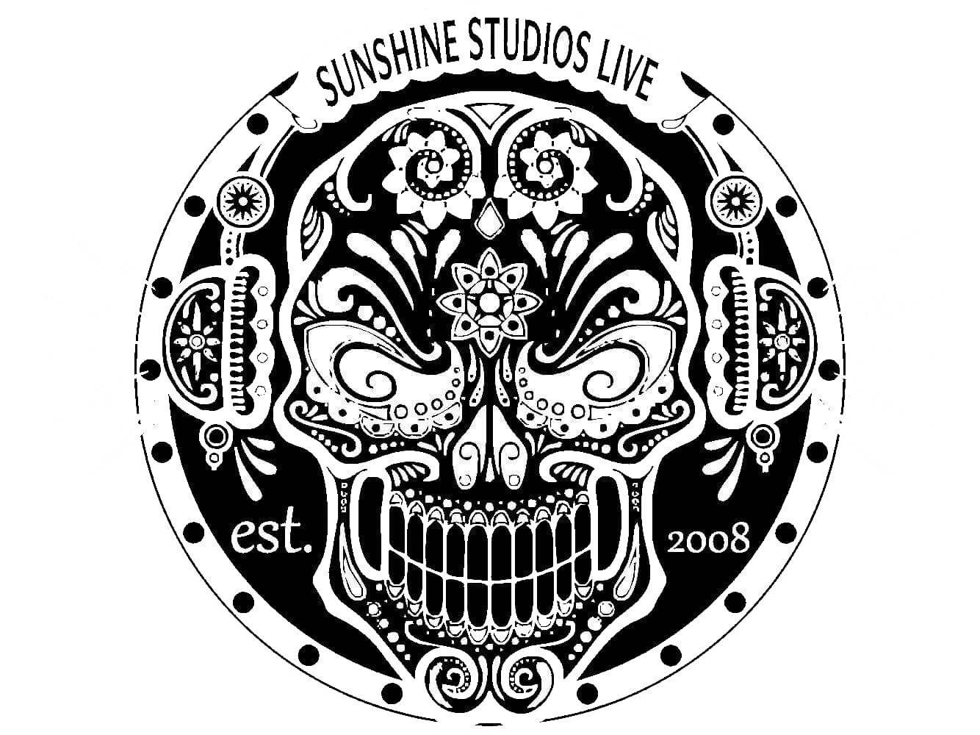

January 14, 2020

This letter is written on behalf of the Cryptic Writings Megadeth tribute band who has played Sunshine Studios Live numerous times and has sponsored some of our best shows to date. They’re over all enthusiasm for music and creativeness for what they do is so in gulfing to audiences and engineers alike. If we have ever seen a local tribute band know how to pack a venue, it would be them! They each bring such an essence to the overall spectrum of their sound that captivating a huge audience comes naturally. Their intrapersonal skills and open-minded attitudes make them such a great band to work with. Their charismatic performances and the technicality set them apart from the “everyday” tribute band we have in here to perform. Cryptic Writings, we truly believe have all it takes to excel in the music industry of today’s demanding standards.

Sincerely,

Christina Korte

Vice President, Director

Musical Talent Operations

Sunshine Studios Live LLC. 3970 Clearview Frontage Rd. Colorado Springs, CO. 80911

[sunshinestudios@csprings.com](mailto:sunshinestudios@csprings.com) [www.sunshinestudioslive.com](http://www.sunshinestudioslive.com) www.facebook.com/SSLiveRocks

719.392.8921